# **Deploying an RDS MariaDB Instance with EC2 in a Custom VPC**

This documentation provides a step-by-step guide for setting up an Amazon RDS database instance with MariaDB and accessing it from an EC2 instance within a custom VPC configuration. The architecture spans three Availability Zones (AZs), including one public and two private subnets, and leverages the AWS Free Tier.

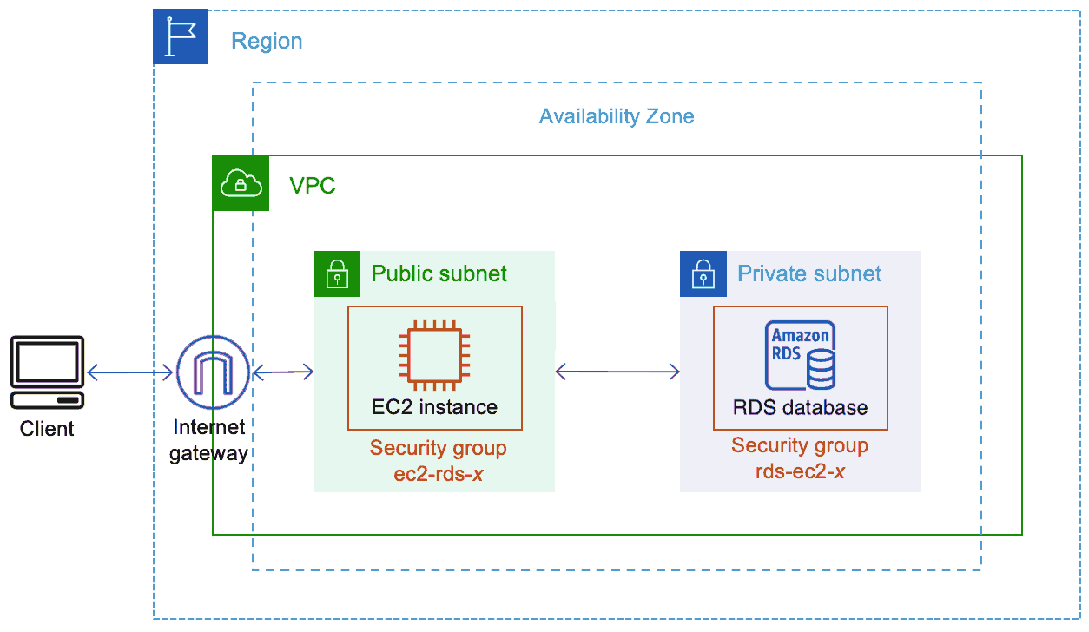

## **🎯 Objectives**

* **Create a Custom VPC**: Set up a VPC with three subnets across different AZs.
* **Deploy EC2 and RDS Instances**: Launch an EC2 instance and an RDS MariaDB instance in the VPC.
* **Configure Network Access**: Ensure secure access between the EC2 instance and the RDS instance.
* **Access RDS from EC2**: Connect to the RDS MariaDB database from the EC2 instance using MariaDB client tools.

## **🏗 Architecture**

The architecture includes:

* **VPC**: A custom VPC spanning three Availability Zones.
* **Subnets**:
  + One public subnet for the EC2 instance with internet access.
  + Two private subnets for RDS to enhance security and availability.
* **Internet Gateway**: Provides internet access to the public subnet.
* **Route Tables**: Configured for appropriate traffic routing between subnets and to the internet.
* **Security Groups**: Configured to control inbound and outbound traffic to the EC2 and RDS instances.

## **📋 Steps to Deploy the Architecture**

### **1. Create a Custom VPC**

1. **Create VPC**:
   * Navigate to the VPC dashboard in the AWS Console.
   * Create a new VPC with a CIDR block, e.g., 10.0.0.0/16.

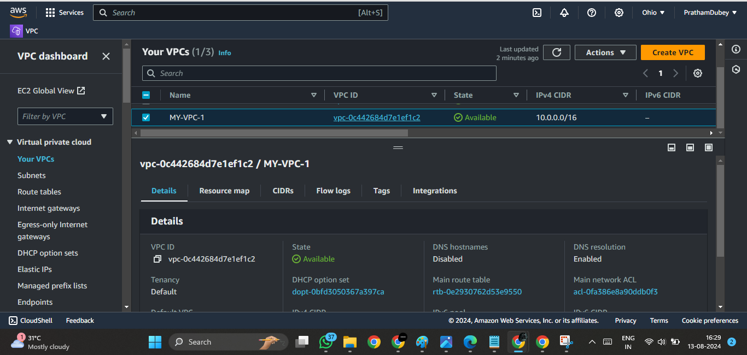

1. **Create Subnets**:
   * **Public Subnet**: Create a public subnet in one AZ (e.g., 10.0.1.0/24).

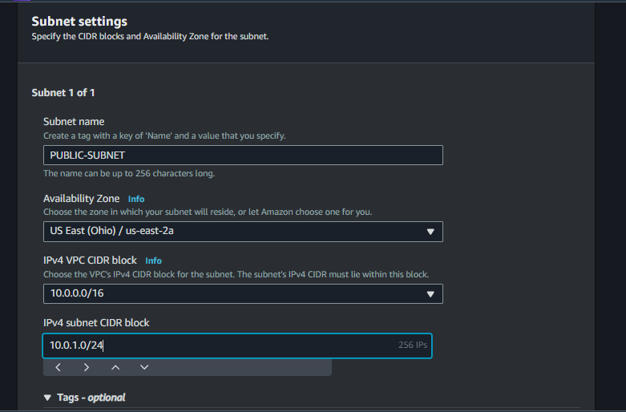

* + **Private Subnets**: Create two private subnets in different AZs (e.g., 10.0.2.0/24 and 10.0.3.0/24).

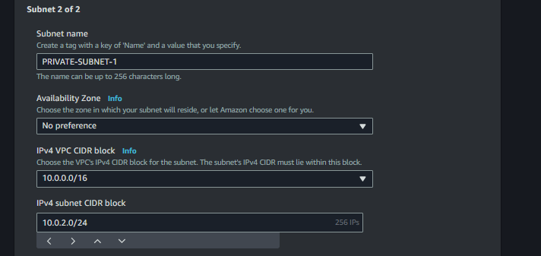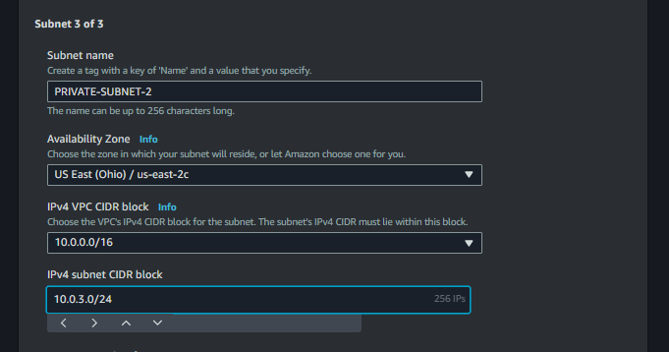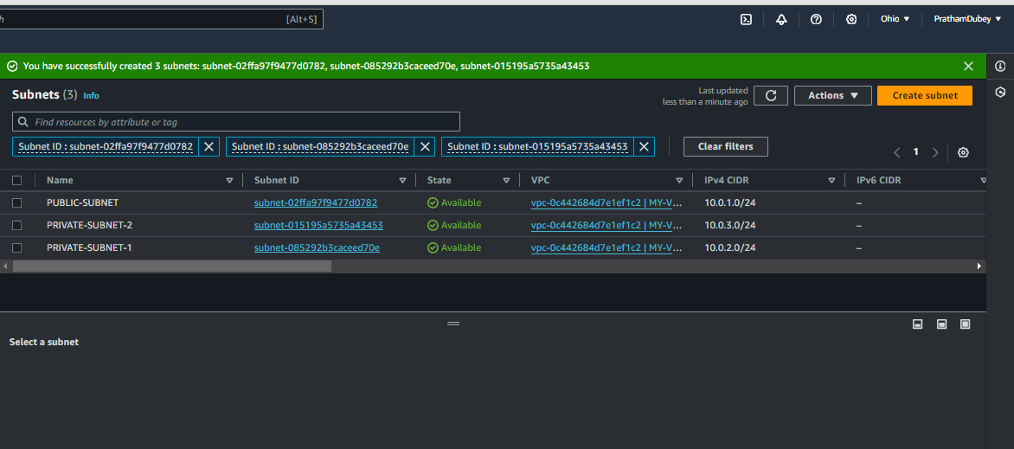

1. **Create Internet Gateway**:
   * Attach an Internet Gateway to the VPC.

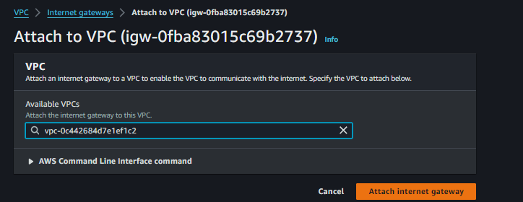

1. **Configure Route Tables**:
   * **Public Route Table**: Add a route for internet traffic (0.0.0.0/0) to the Internet Gateway.

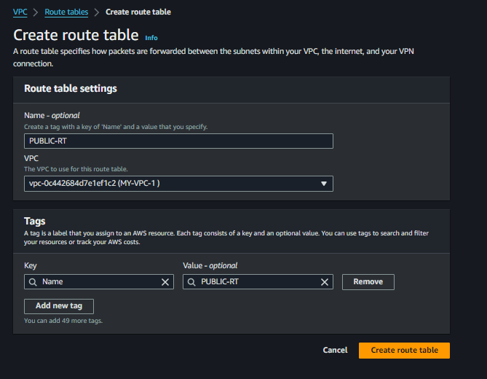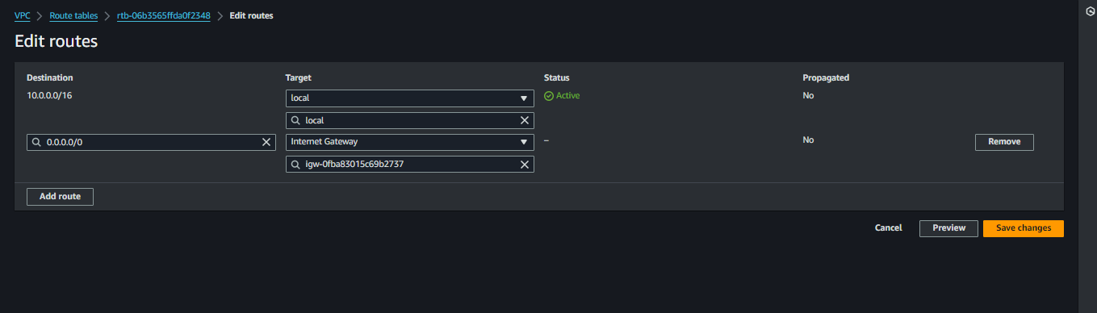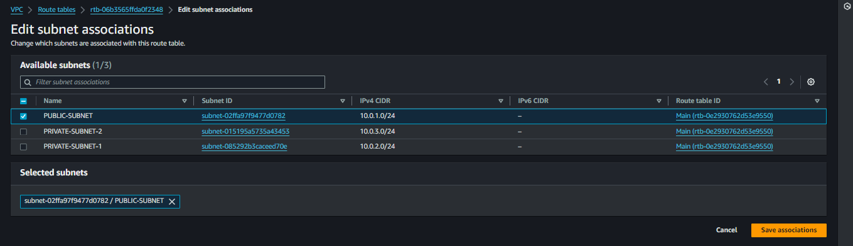

* + **Private Route Table**:

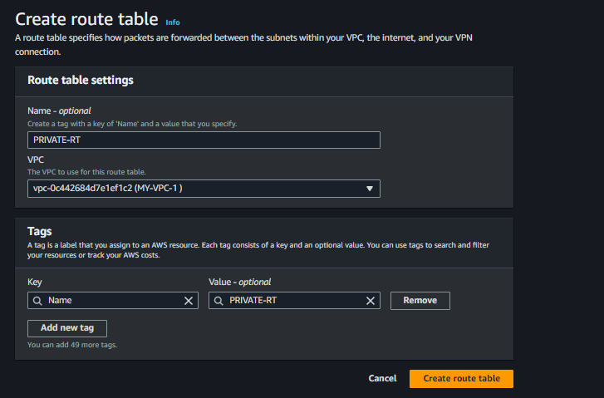

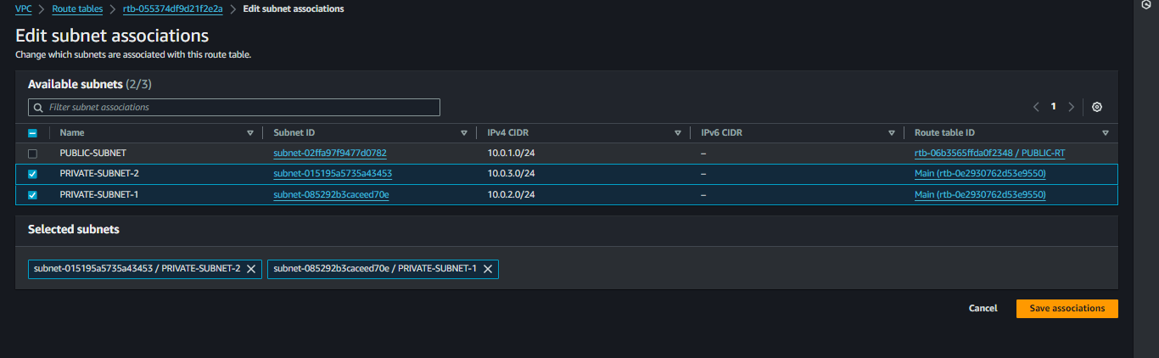

**2. Launch an EC2 Instance**

1. **Launch EC2 Instance**:
   * Choose an Amazon Linux 2 AMI (Free Tier eligible).
   * Place it in the public subnet.
   * Assign a public IP for internet access.
2. **Configure Security Group for EC2**:
   * Allow inbound SSH access (port 22) from your IP address.
   * Allow outbound traffic to the internet.

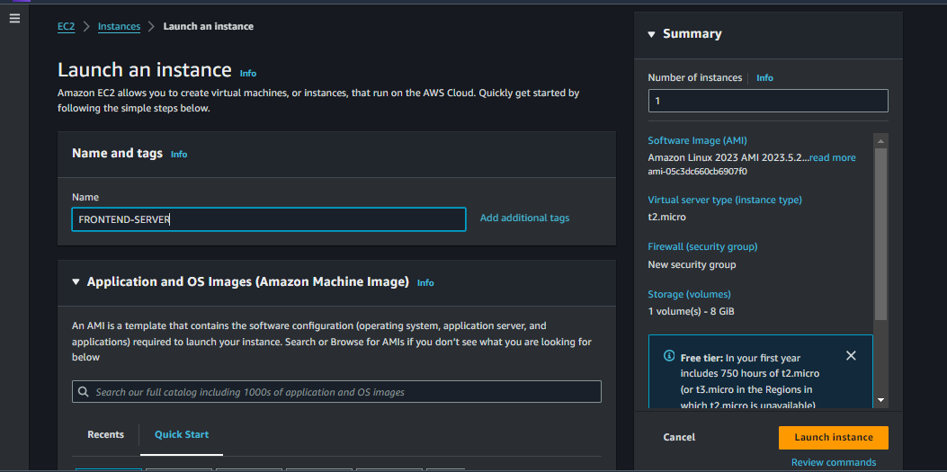

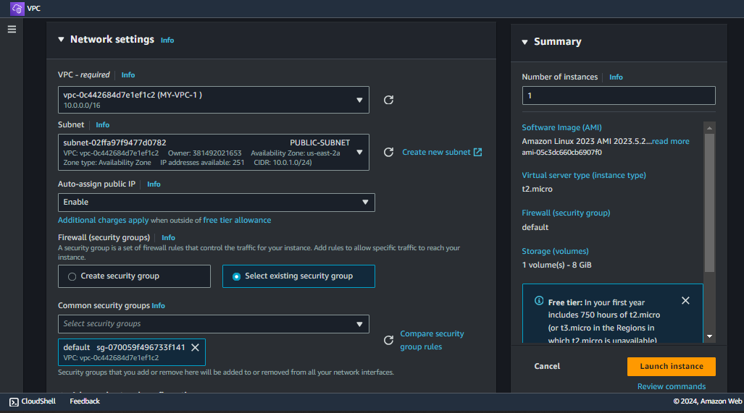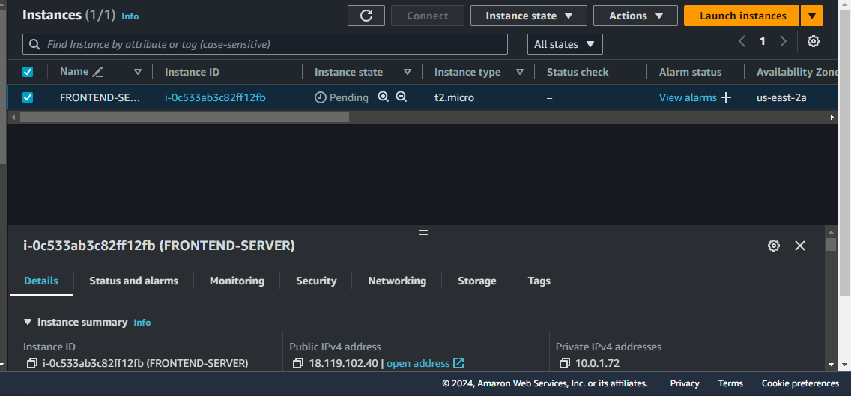

### **3. Set Up RDS MariaDB Database**

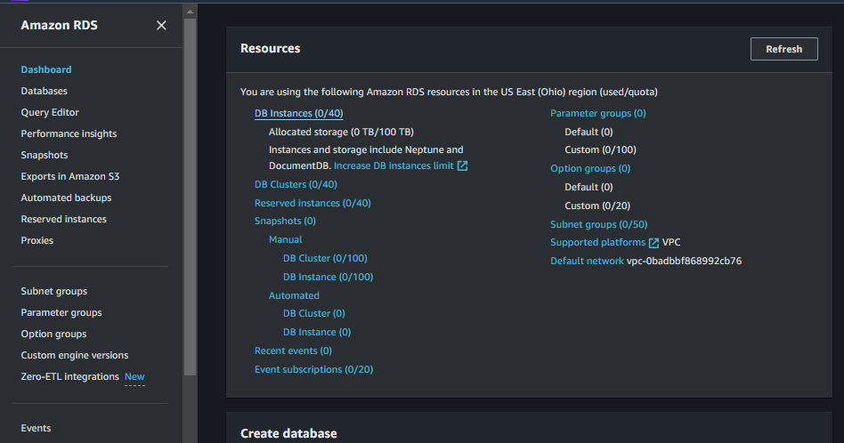

1. **Launch RDS Instance**:
   * Choose the MariaDB database engine (Free Tier eligible).

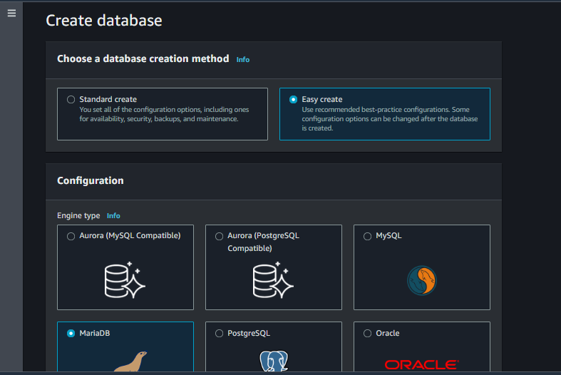

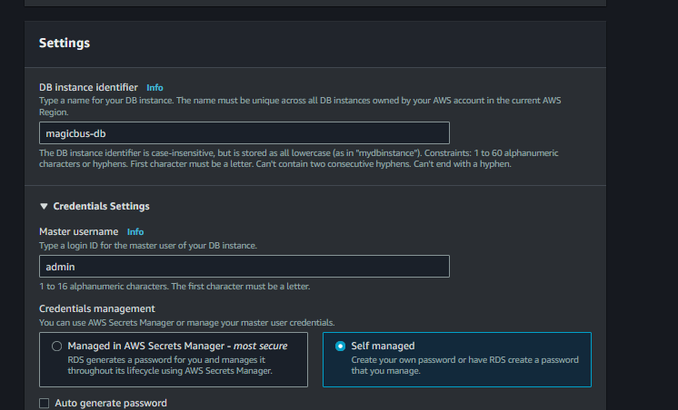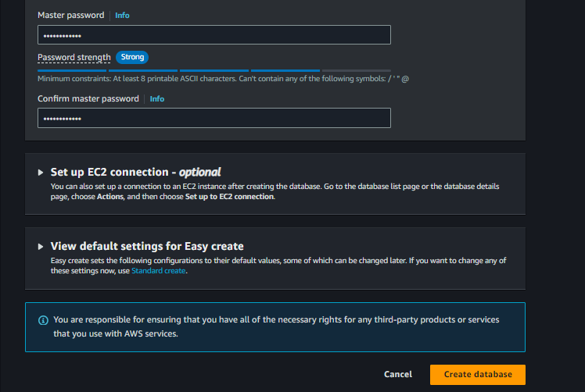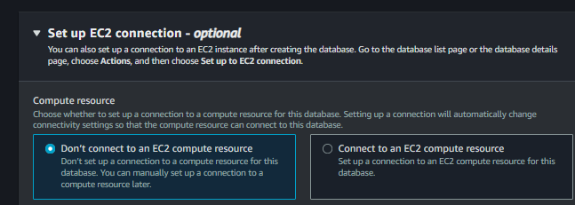

* + Select "Do not create" for public accessibility (private access only).

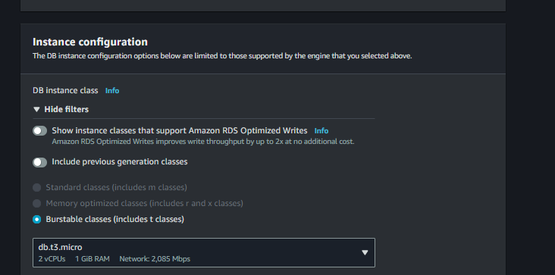

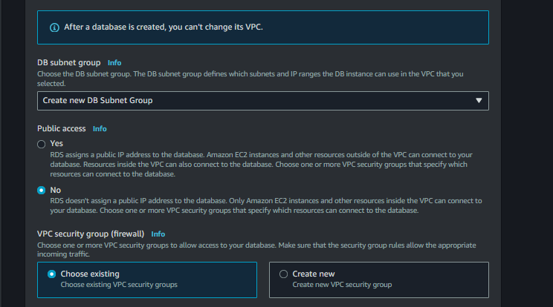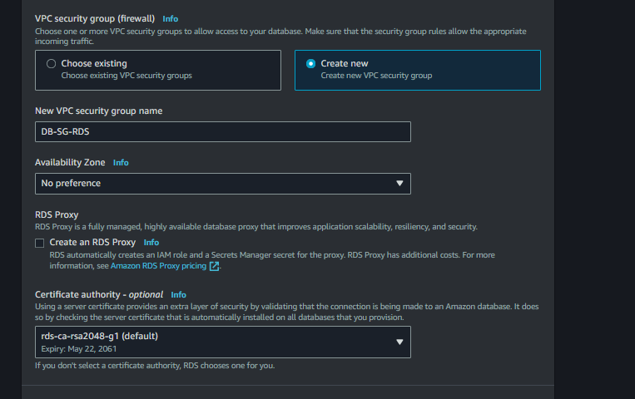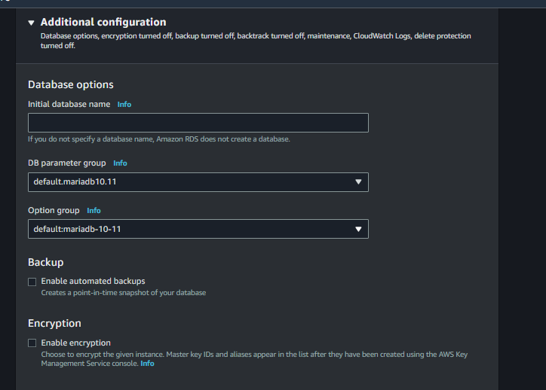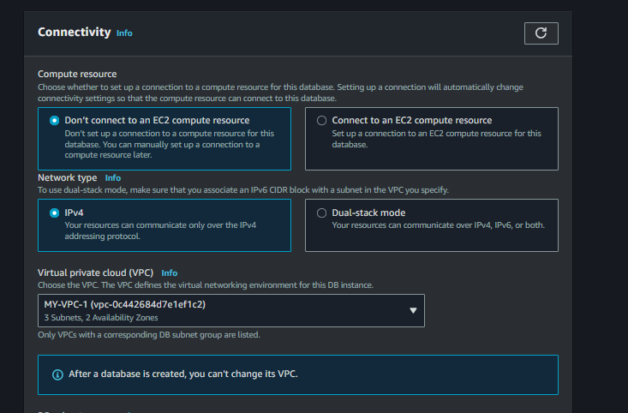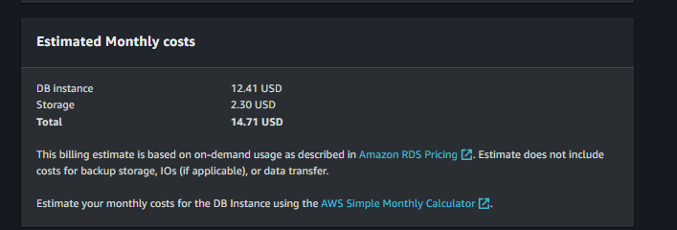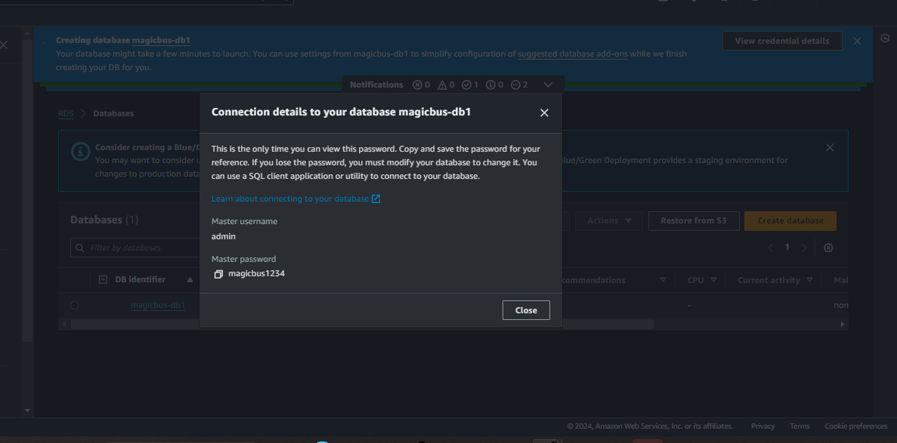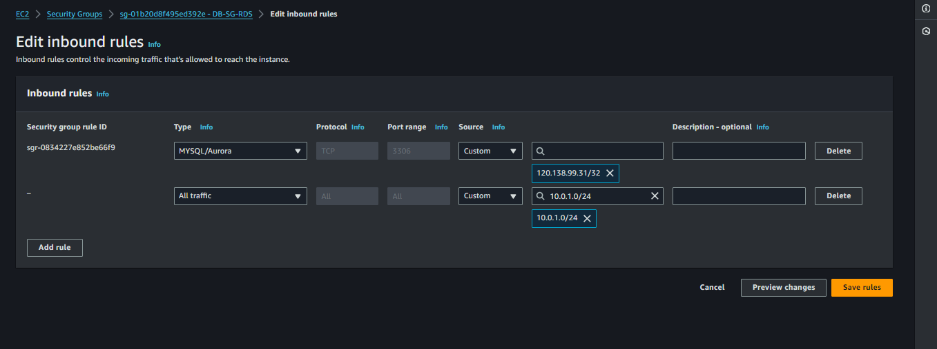

* + Place the RDS instance in the two private subnets using subnet groups.

1. **Configure Security Group for RDS**:
   * Allow inbound MariaDB access (port 3306) from the EC2 security group.
   * Allow outbound traffic to the internet for updates and patching.



### **Create and Query the Student Table**

### **Connect to the RDS Instance: bash mysql -h your-rds-endpoint -u your-username -p**

### 

**(1)Show databases ;**

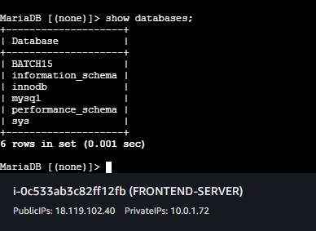

Create the Student Table:  
sql  
  
USE BATCH15;

CREATE TABLE Students (

StudentID INT AUTO_INCREMENT PRIMARY KEY,

FirstName VARCHAR(50),

LastName VARCHAR(50),

Age INT,

Major VARCHAR(100)

);

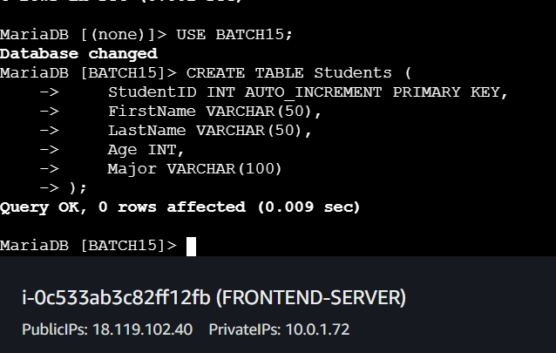

Insert Sample Data:  
sql  
  
INSERT INTO Students (FirstName, LastName, Age, Major) VALUES

('Alice', 'Johnson', 20, 'Computer Science'),

('Bob', 'Smith', 22, 'Mathematics'),

('Charlie', 'Brown', 19, 'Physics'),

('Daisy', 'Miller', 21, 'Chemistry'),

('Eve', 'Davis', 23, 'Biology');

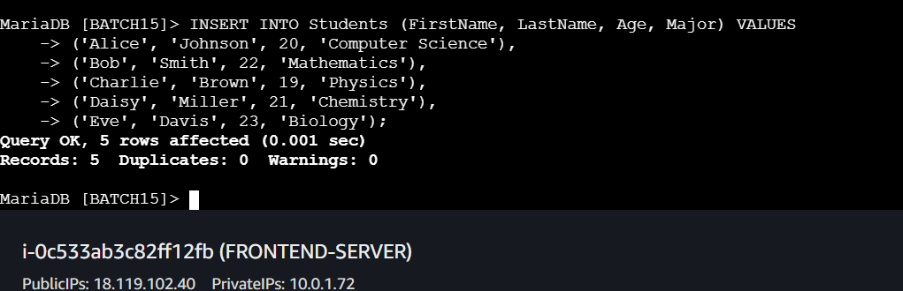

1. Perform SQL Queries:

Retrieve All Students:  
sql  
  
SELECT * FROM Students;

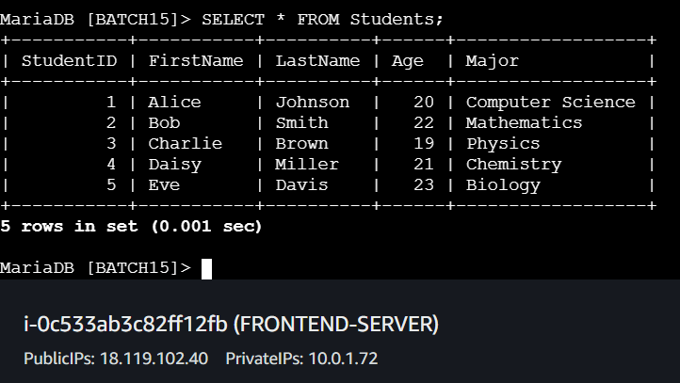

Find Students by Major:  
sql  
  
SELECT * FROM Students WHERE Major = 'Computer Science';

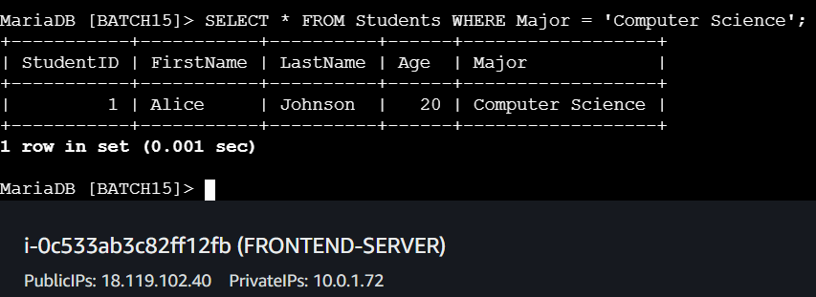

Count Students by Age:  
sql  
  
SELECT Age, COUNT(*) AS NumberOfStudents FROM Students GROUP BY Age;

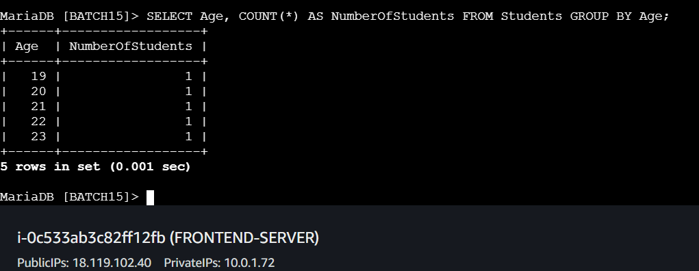

Update a Student's Major:  
sql  
  
UPDATE Students SET Major = 'Data Science' WHERE FirstName = 'Alice' AND LastName = 'Johnson';

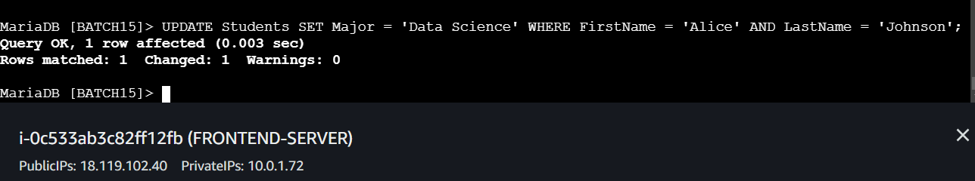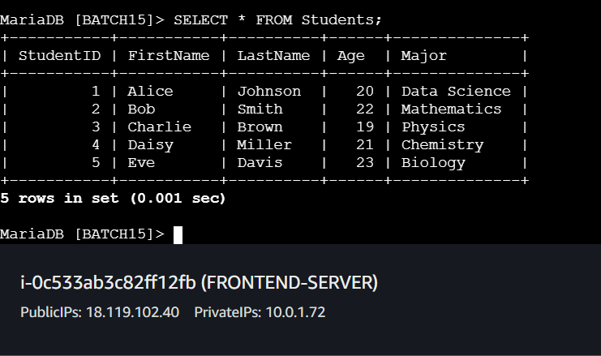

Delete a Student Record:  
sql  
  
DELETE FROM Students WHERE FirstName = 'Charlie' AND LastName = 'Brown';

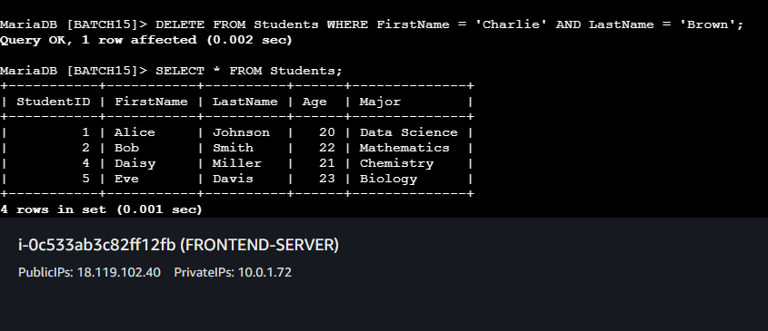

Retrieve Students Older Than 21:  
sql  
  
SELECT * FROM Students WHERE Age > 21;

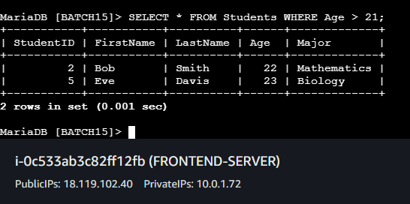

Add a New Student:  
sql  
  
INSERT INTO Students (FirstName, LastName, Age, Major) VALUES ('Frank', 'Wilson', 20, 'Engineering');

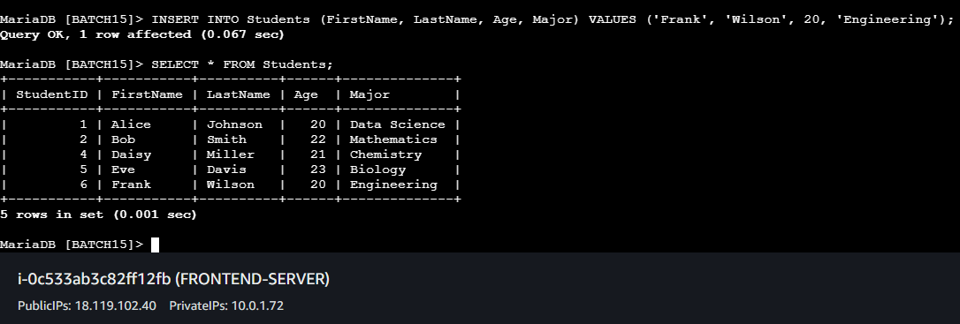

Find Students with 'Biology' Major:  
sql  
  
SELECT * FROM Students WHERE Major = 'Biology';

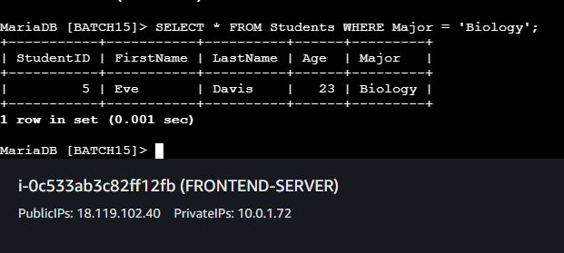

List Students Sorted by Age:  
sql  
  
SELECT * FROM Students ORDER BY Age DESC;

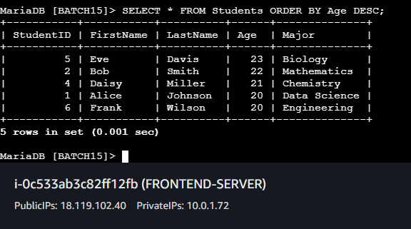

Calculate Average Age of Students:  
sql  
SELECT AVG(Age) AS AverageAge FROM Students;

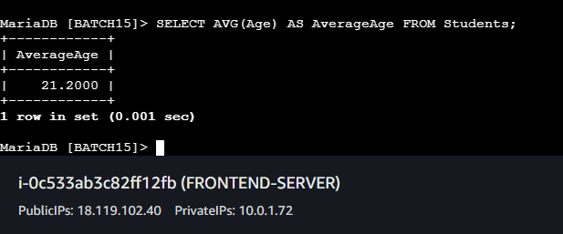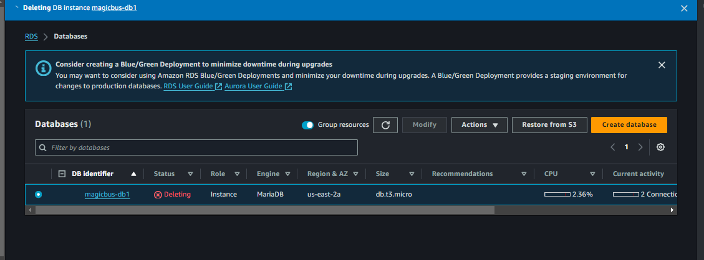

6. Clean Up Resources

* **Terminate EC2 Instance**: When done, terminate the EC2 instance to avoid charges.
* **Delete RDS Instance**: Delete the RDS instance if no longer needed.
* **Remove Networking Components**: Delete the VPC, subnets, and associated resources if not in use.

## **📊 Conclusion**

This setup demonstrates how to deploy a secure and efficient architecture on AWS using EC2 and RDS with MariaDB within a custom VPC. By placing your RDS instance in private subnets, you ensure better security and control over your database resources while maintaining the ability to manage and query them from an EC2 instance in a public subnet. This architecture is ideal for applications that require a secure backend database service accessed by a publicly accessible application server.

## **🔗 Additional Resources**

* [AWS VPC Documentation](https://docs.aws.amazon.com/vpc)
* [AWS EC2 Documentation](https://docs.aws.amazon.com/ec2)
* [AWS RDS Documentation](https://docs.aws.amazon.com/rds)